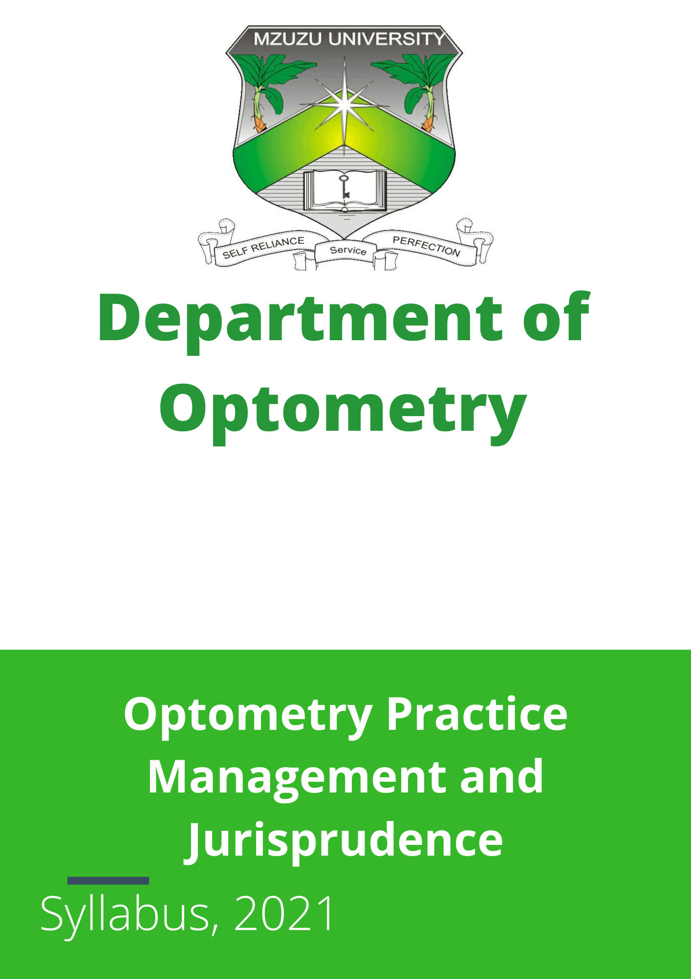
Contents
Introduction 3
Lecture 1 Overview of Legal Principles 4
Lecture 2 Legal Forms of Business Organization 6
Lecture 3: Taxation 7
Lecture 4 Insurance 8
Lecture 5 Business Plan 9
Lecture 6 Setting up the business 10
Lecture 7 Marketing 12
Lecture 8 Selling and communication 13
Lecture 9 Management Theory 14
Lecture 10 Administration of the Practice 16
Lecture 11 Financial Management 18
Lecture 12 Personnel management 20

Introduction
The course aims to prepare the students to manage various aspects of optometric services including the marketing and legal aspects of practice.
BROAD OBJECTIVE
By the end of this course, the student should be able to fully understand the management of an optometric practice.
SPECIFIC OBJECTIVES:
By the end of the module the student should be able to:
1 Describe the proper management of optometric services.
2 Apply essential tools to run an efficient optometric practice
3 Describe legal aspects regulating Optometry
4. Develop a Business plan for an Optometric practice
ASSESSMENT METHODS:
Continuous Assessment
Written tests
Assignments
Business Plan

Lecture 1 Overview of Legal Principles
Topic: Overview of Legal Principles
Aim:
This lecture introduces the students to the legal principles that affect the operation of an optometry practice.
Objectives:
At the end of this lecture, students should be able to:
- Apply legal principles to the operation of an optometry practice.
- Differentiate between legislation and common (judge-made) law.
- Describe the elements of a contract and how they apply to the handling of patients in the clinic.
- Describe the application of consumer law to the patient-optometrist relationship.
Time: 1 hour
Materials Required: Recorded Videos, Interview Videos
Method: Lecture Videos, Group Presentations, and Discussions
Assessment: Pop Quiz
Scenario 1:
Description:
Mrs. P visited your clinic on the 28th of April and returned with two complaints:
- Complaint about Eye Drops:
  - She developed red eyes after using the prescribed medication.
  - The condition worsens despite following the prescribed dosage.
  - Upon examination, you notice the eye drop container's tip is dirty. Mrs. P claims it was like that when she received it, and a sample from your store confirms the condition. Additionally, she admits to placing the dropper tip directly on her eyes.
- Complaint about Designer Frames:
  - Mrs. P paid for Gucci designer frames, but discovered they were fake when the label fell off and the color changed after one use.
Questions to Address the Scenario:
- How would you handle this case using the legal principles discussed in the lecture?
- What steps would you take to address the first complaint about the eye drops?
- How would you handle the second complaint regarding the fake Gucci frames?
Keywords: Legal principles Legislation Common law Contract elements Consumer law Negligence Liability Quality control

Lecture 2 Legal Forms of Business Organization
Topic: Legal Forms of Business Organization
Aim:
This topic acquaints the student with the different forms of business organization for an optometry practice.
Objectives:
At the end of this lecture, students should be able to:
- Describe forms of business organization for an eye clinic.
- Identify the advantages and disadvantages of each.
- Determine the best form of business for Malawi.
Time: 1 hour
Materials Required: Recorded Videos, Interview Videos
Method: Lecture Videos, Group Presentations, and Discussions
Assessment: Pop Quiz
Scenario 2:
Description:
Two years after graduation, five members from your class along with two senior colleagues decide to open an NGO for providing free eye care services to the needy within the community.
Questions to Address the Scenario:
- What steps would you take to register the NGO?
- Which legal form of business would be the best to choose for this NGO in Malawi and why?
Keywords: Business organization NGO registration Legal forms Advantages and disadvantages Optometry practice

Lecture 3: Taxation
Topic: Taxation
Aim:
This topic familiarizes the student with the taxation principles that relate to the running of an optometry practice.
Objectives:
At the end of this lecture, students should be able to:
- Describe types of direct taxes and how they apply to an optometry practice in Malawi.
- Describe the types of indirect taxes and how they apply to the running of a practice.
- Explain other regulations required to run a practice, specifically for Malawi.
Time: 1 hour
Materials Required: Recorded Videos, Interview Videos
Method: Lecture Videos, Group Presentations, and Discussions
Assessment: Pop Quiz
Scenario 3:
Description:
During the next holiday, you have been posted to a private clinic in Blantyre. On your second day in the clinic, officers from the Malawi Revenue Authority (MRA) arrive, demanding to see the director. They claim the clinic has been owing tax returns.
Questions to Address the Scenario:
- What specific questions would you ask the MRA officers to clarify the tax issues?
- What types of taxes are you expecting from the clinic, and which are you not expecting?
- What other possible regulations would you expect the clinic to comply with?
Keywords: Taxation principles Direct taxes Indirect taxes Tax compliance Optometry practice Malawi Revenue Authority (MRA) Regulatory compliance

Lecture 4 Insurance
Topic: Insurance
Aim:
This topic introduces the student to the concepts of insurance and its relevance to optometry practice.
Objectives:
At the end of this lecture, students should be able to:
- Describe the various insurance packages required for an optometry practice.
- Determine those required for eye care practice in Malawi.
Time: 1 hour
Materials Required: Recorded Videos, Interview Videos
Method: Lecture Videos, Group Presentations, and Discussions
Assessment: Pop Quiz
Scenario 4:
Description:
Recall the lady from Scenario 1. Consider what type of insurance would have been helpful for the two issues she faced.
Questions to Address the Scenario:
- What type of insurance would have been helpful for the issue with the eye drops?
- What type of insurance would have been helpful for the issue with the Gucci frames?
- Why would you encourage all clinic owners to acquire insurance in Malawi?
Keywords: Insurance concepts Insurance packages Optometry practice Liability insurance Product insurance Professional indemnity Malawi

Lecture 5 Business Plan
Topic: Business Plan
Aim:
This topic equips the student with the skills needed to develop a business plan for an eye care practice.
Objectives:
At the end of this lecture, students should be able to:
- Describe parts of a business plan.
- Explain the steps in writing a business plan.
- Apply the principles of a business plan to planning an optometry practice.
Time: 1 hour
Materials Required: Recorded Videos, Interview Videos
Method: Lecture Videos, Group Presentations, and Discussions
Assessment: Pop Quiz
Scenario 5:
Description:
Two years after your internship, you receive a call from an uncle in the USA who wants to assist you in opening a clinic. Before he sends the money, he would like to have an idea of what is required for the business.
Questions to Address the Scenario:
- What would be your first considerations when preparing the business plan?
- What information would you include in the business plan?
- How would you go about writing the business plan?
Keywords: Business plan Business planning Optometry practice Financial planning Market analysis Operational planning Strategic planning

Lecture 6 Setting up the business
Topic: Setting Up the Business
Aim:
This topic introduces the student to the requirements for setting up a practice.
Objectives:
At the end of this lecture, students should be able to:
- Explain the considerations for choosing a practice location.
- Describe the details required for designing different practice options.
- Identify the full equipment required for all aspects of the practice.
- Design their future practice and include it in their business plan.
Time: 1 hour
Materials Required: Recorded Videos, Interview Videos
Method: Lecture Videos, Group Presentations, Discussions, Clinic Visits, and Observation
Assessment: Pop Quiz, Group Report
Scenario 6:
Description:
Your uncle has just called asking about your draft business plan. He has the following questions for you:
- Which city will your practice be located in and why?
- Which location within the city would you choose?
- What considerations would you have in mind while selecting?
- What equipment list would you include in the business plan?
- What will be the design you have in mind for the practice?
Activity:
Visit the AVC and observe the design. Each clinic group should come with a report on their observations and make recommendations to the department for changes required to make the practice better. This will be presented in class and submitted as a group report.
Questions to Address the Scenario:
- What would be your first considerations for setting up the business?
- What information would you include in your business plan?
- How would you go about writing the plan?
Keywords: Practice location Practice design Equipment requirements Business planning Optometry practice Clinic setup

Lecture 7 Marketing
Topic: Marketing
Aim:
This topic acquaints the student with marketing principles for the optometry practice.
Objectives:
At the end of this lecture, students should be able to:
- Differentiate between merchandising and marketing.
- Explain the marketing mix and its implication for the optometry practice.
- Discuss types of advertising and their role in promoting the practice.
- Explain factors affecting the cost of advertising.
- Explain the role of internet promotion in promoting the practice.
Time: 1 hour
Materials Required: Recorded Videos, Interview Videos
Method: Lecture Videos, Group Presentations, Discussions, Clinic Visits, and Observation
Assessment: Pop Quiz
Scenario 7:
Description:
In the business plan, you need to outline how you plan to promote your new practice.
Questions to Address the Scenario:
- How do you plan to promote your new practice?
- Which aspects of the marketing mix will affect your practice and why?
Keywords: Marketing principles Merchandising vs. marketing Marketing mix Advertising types Cost of advertising Internet promotion Optometry practice Promotion strategies

Lecture 8 Selling and communication
Topic: Selling and Communication
Aim:
This topic acquaints the student with the concepts of selling and effective communication in the clinic.
Objectives:
At the end of this lecture, students should be able to:
- Describe the steps to selling.
- Explain questioning techniques and their relevance to communication.
- Describe different personalities and how to relate to them.
- Identify steps to effective problem-solving for the patient.
Time: 1 hour
Materials Required: Recorded Videos, Interview Videos
Method: Lecture Videos, Group Presentations, Discussions, Clinic Visits, and Observation
Assessment: Pop Quiz
Scenario 8:
Description:
It has been two weeks since the opening of the practice, but sales have been very low. Patients have been coming in for the free eye test, but they seem not to pick up their prescriptions. Earlier that week, a woman came in complaining about her glasses while you were at the reception.
Questions to Address the Scenario:
- What would be your course of action to ensure the business improves?
- If you decide to hold a seminar for your staff members, which aspects of Lecture 8 would you include and why?
Keywords: Selling techniques Effective communication Questioning techniques Personality types Problem-solving Patient relations Optometry practice

Lecture 9 Management Theory
Topic: Management Theory
Aim:
This topic acquaints the student with the concepts of management, its functions, and its application in an optometry practice.
Objectives:
At the end of this lecture, students should be able to:
- Describe the functions of management.
- Differentiate between management and supervision.
- Explain the management skill set and their role in managing an eye clinic.
Time: 1 hour
Materials Required: Recorded Videos, Interview Videos
Method: Lecture Videos, Group Presentations, Discussions, Clinic Visits, and Observation
Assessment: Pop Quiz
Scenario 9:
Description:
You have just resumed work as the optometrist in charge of Modern Optical. On your first day at work, you see that the office is not running the way it should. During your second consultation of the morning, the receptionist asks for permission to see a friend. Thirty minutes later, the security guard enters to collect money for fuel. Feeling very annoyed, you step out of the consulting room to see the front desk manager and the technician sitting in the consulting room discussing.
Questions to Address the Scenario:
- What would be your reaction to this situation?
- Using management theory, what steps would you take to correct the situation?
Keywords: Management functions Management vs. supervision Management skills Office management Optometry practice Team management Problem-solving

Lecture 10 Administration of the Practice
Topic: Administration of the Practice
Aim:
This topic acquaints the student with the day-to-day administration of the optometry practice.
Objectives:
At the end of this lecture, students should be able to:
- Differentiate delegate-able tasks within the optometry practice.
- Describe the value of policies and procedures in the day-to-day running of the practice.
- Explain the various types of records in an optometry practice and their uses.
- Describe the stock control systems available for an optometry practice.
- Demonstrate the use of the stock turn.
- Explain the legal requirements concerning records in optometry practice, especially in Malawi.
Time: 1 hour
Materials Required: Recorded Videos, Interview Videos
Method: Lecture Videos, Group Presentations, Discussions, Clinic Visits, and Observation
Assessment: Pop Quiz
Scenario 10:
Description:
As the optometrist in charge of HI Vision Eye Clinic, you notice on your first day that things are not going as they should. Everyone comes to you for approval on everything. You also notice differences in the way the two receptionists and the technician’s work. After seeing your first follow-up patient, you observe that the receptionist could not find the patient's record from the previous visit.
Questions to Address the Scenario:
- What measures would you take to ensure things are moving as they should?
- What recommendations would you give to the board of directors?
Keywords: Administration Delegation Policies and procedures Records management Stock control systems Stock turn Legal requirements Optometry practice

Lecture 11 Financial Management
Topic: Financial Management
Aim:
This topic acquaints the student with financial management principles for opening a new practice and running an existing optometry practice.
Objectives:
At the end of this lecture, students should be able to:
- Draft a financial plan for an optometry practice.
- Calculate the profit required for ROI, turnover, and breakeven point.
- Draft a monthly budget.
- Describe the various sources of finance for a new practice.
- Explain the requirements for obtaining funds from financiers.
- Explain the double-entry bookkeeping principles.
- Describe the accounting process for a business or optometry practice.
Time: 1 hour
Materials Required: Recorded Videos, Interview Videos
Method: Lecture Videos, Group Presentations, Discussions, Clinic Visits, and Observation
Assessment: Pop Quiz
Scenario 11:
Description:
Uncle B could not complete the money required for your new practice. Finally, in August, you managed to open a practice in Lilongwe, though not as large as you expected. A friend introduced you to a bank manager for some funds.
Questions to Address the Scenario:
- What information would you provide in your updated business plan to convince the bank manager that your business is worth investing in?
- What specific aspects would you maintain financially in the few months you have operated to make this possible?
Keywords: Financial management Financial plan ROI Turnover Breakeven point Monthly budget Sources of finance Double-entry bookkeeping Accounting process Optometry practice Investment

Lecture 12 Personnel management
Topic: Personnel Management
Aim:
This topic acquaints the student with the process of employing staff for a business, specifically an optometry practice.
Objectives:
At the end of this lecture, students should be able to:
- Differentiate between an employee and a contractor.
- Determine the benefits and disadvantages of each type of worker.
- Describe the five steps for employment.
- Explain the importance of the job description.
Time: 1 hour
Materials Required: Recorded Videos, Interview Videos
Method: Lecture Videos, Group Presentations, Discussions, Clinic Visits, and Observation
Assessment: Pop Quiz
Scenario 12:
Description:
Yanko Clinic is having problems with one of their staff members who was employed two months ago. The staff member refuses to do most of what was assigned and is already demanding a salary increase.
Questions to Address the Scenario:
- What questions would you ask the management regarding this situation?
- What would you recommend to them for the future employment of new staff?
Keywords: Personnel management Employee vs. contractor Employment benefits Employment disadvantages Employment steps Job description Staff management Optometry practice

Last Revision June 2024

